American University of Sharjah

College of Engineering

Department of Computer Science and Engineering

CMP 354 Mobile Application Development

Prof. Tamer Shanableh

Spring 2023

Course Project

Title: **Purrfect Therapy**

User Guide

Name: Mohamed Alshafai & Amjad Hasan

ID: b00087311 & b00089059

Due Date: May 7, 2023

Contents

Introduction: Signup 3

Homepage 3

Map 5

Profile 7

Help 15

References 17

# Introduction: Signup

Welcome to the Purrfect Therapy, where we try to help you in your times of need. As you can see below to, if you already have an account, enter your credentials and log in. However, if you don’t, click on the Sign Up text to take you to the sign up window. Enter a valid email address, a password (minimum 6 characters), repeat the password, and a valid phone number (minimum 10 characters).

# Homepage

Congratulations, you have now created your free account with Purrfect Therapy. Now, you enter the homepage, where you can see a search bar that can be used to search for a cat by its name (do keep in mind it’s case sensitive); press done in the keyboard after entering the name. Below it, you can see a list of available cats with a drop down to decide how to order them and a choice between ascending and descending order. To book a session with a cat, press on any of the cats in the list and pressing the “BOOK” button to finish your booking. During the booking of the cat you are met with more information regarding the cat and the email of the owner to contact to set up a meeting with.

Alternatively, you can search for your favorite cat to check if they’re available for booking through the search bar. By entering the name and pressing done, a list of the matches appears, and you can press on the any cat in the list to view their details and book a session similar to the previous method.

# Map

Additionally, press on the options menu (i.e., the 3 dotted line at the top right) to find the “Map” option where you can book cats based on their location of the map. By clicking on a marker you get a pop up with small details on the cat. By pressing on the pop up, you’ll get a full description similar to before and an option to “BOOK” the cat for a session as well. We’ll proceed with this way to showcase. You have no booked a session with the selected cat, and its marker will disappear from the map, as well as the previous menu.

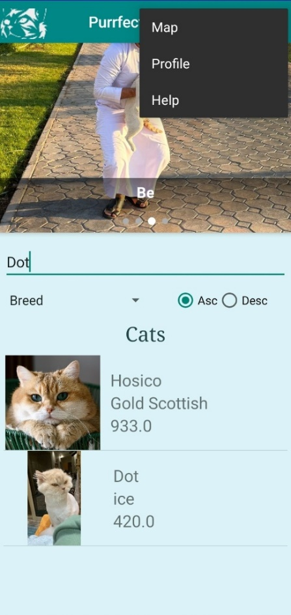

# Profile

Let’s explore more. Go back to the homepage and to the options menu at the top right to find the “Profile” option. In your profile page, you will find your email, contact number, the option to get notified of new cats, and a list of the cats you offer for therapy sessions; you currently don’t own a cat :(.

By clicking on the options menu, similar to before, you will find 3 new options in the profile page. To find out the cats owned by you booked for therapy sessions, press on the “Cats Away in Sessions” option. If someone booked a cat of your, they’ll appear on this page, and you’ll be able to return them back to being available after dealing with the customer through their contact information. Going back to the profile menu, if you press on the “Cats for my Therapy” option, you’ll see the cats you’ve booked to have therapy sessions with. By clicking the “RETURN CAT” button, you’ll be able to mark the cat as returned for its owner after discussing the return of the cat with them through their contact information.

Moreover, the 3rd option “Add a Cat for Offering Therapy”, allows you to add a cat to offer therapy sessions with. Once you’ve pressed the option, you’ll be met with a dialog to choose between “GPS,” “MAP,” or “CANCEL.” To automatically have a cat added through your current location, press on “GPS” (do note that you may be asked to allow GPS or access to current location). After filling in the fields and possibly uploading an image, you can press the “ADD” button to add the new cat to your profile. However, if the app couldn’t access your current location, you’ll be asked to either “USE MAPS” or “CANCEL” the request. As such, let try adding through the map. After being transferred to the map, find the wanted location, and press and hold on the location to add the cat. After following the previous steps to fill in the fields, you’ll be met with a success prompt after the cat is successfully added to the database.

Now, you’ve added your first cat as you can see in your profile page. If you wish to edit their info press on the cat in the list where you can edit their fields, add or remove an image, or delete the cat from the database; make sure to add the picture again, because it defaults to removing it. However, you won’t be able to edit a booked cat. Additionally, by checking the “Notify Me of New Cats” checkbox, you’ll be able to get notifications of new cats once they are added to the database. When pressed, the notification will take you to the home page, and autofill in the cat’s name for you to search.

# Help

Lastly, the “Help” option can be found in both the home and profile page, which will display brief details about the options in the menu and their functionality. Enjoy your experience!

# References

Uploading image and retrieving Image from DB: <https://androidknowledge.com/store-retrieve-data-in-firebase-realtime-database-using-android-studio/>, <https://youtu.be/Hn89s4oCdS8>

Image Slider: <https://youtu.be/fiSWKebAZg8>

Making Custom List Adapter with images: <https://stackoverflow.com/questions/22064691/how-to-add-images-to-listview-in-android>

Login page XML adapted from:

can you create a resource file for android studio that's for an aesthetic login page

ChatGPT

Sure, I can help you create a resource file for an aesthetic login page in Android Studio. Here is an example of a login page layout with some styling that you can use as a starting point:

xmlCopy code

<?xml version="1.0" encoding="utf-8"?> <LinearLayout xmlns:android="http://schemas.android.com/apk/res/android" android:layout_width="match_parent" android:layout_height="match_parent" android:gravity="center" android:orientation="vertical" android:padding="16dp"> <ImageView android:layout_width="wrap_content" android:layout_height="wrap_content" android:src="@drawable/logo" android:layout_gravity="center_horizontal"/> <EditText android:id="@+id/username_edittext" android:layout_width="match_parent" android:layout_height="wrap_content" android:hint="Username" android:background="@drawable/edittext_bg" android:textColorHint="@color/hint_text_color" android:padding="12dp" android:layout_marginTop="32dp"/> <EditText android:id="@+id/password_edittext" android:layout_width="match_parent" android:layout_height="wrap_content" android:hint="Password" android:background="@drawable/edittext_bg" android:textColorHint="@color/hint_text_color" android:padding="12dp" android:layout_marginTop="16dp"/> <Button android:id="@+id/login_button" android:layout_width="match_parent" android:layout_height="wrap_content" android:text="Log In" android:background="@drawable/button_bg" android:textColor="@color/white_text_color" android:textSize="18sp" android:padding="12dp" android:layout_marginTop="32dp"/> <TextView android:layout_width="wrap_content" android:layout_height="wrap_content" android:text="Forgot Password?" android:textColor="@color/primary_color" android:textSize="16sp" android:layout_marginTop="16dp"/> </LinearLayout>

In this layout, we have used a **LinearLayout** as the root view, which has its **gravity** set to **center** to center its child views vertically and horizontally.

We have added an **ImageView** to display a logo, and two **EditText** views to allow the user to enter their username and password. We have used a custom background drawable **@drawable/edittext_bg** for the **EditText** views to give them a rounded rectangular shape with a border. The color of the hint text is set using **android:textColorHint**.

We have also added a **Button** to submit the login form, and used a custom background drawable **@drawable/button_bg** to give it a gradient background. The text color of the button is set using **android:textColor**. We have also set the padding of the button to add some space around the text.

Finally, we have added a **TextView** to allow the user to reset their password if they have forgotten it.

You can customize this layout further by modifying the dimensions, colors, and drawables to fit your specific design needs. You can create the custom background drawables using XML files in the **res/drawable/** directory.

**Logo:** <https://www.freepik.com/premium-vector/cat-logo_31573200.htm>